**PROJECT REPORT**

**ON**

**RESULT ANALYSIS**

**Master Of Computer Application <SUMMER PROJECT>**



**Submitted By**

**ARINDAM GHOSH(12)**

**NINAD PATIL(33)**

**SARATH SHANKARANARAYANAN(41)**

**Under Guidance of**

**Prof. Meenakshi Garg**

**VIVEKANANAD EDUCATION SOCIETY’S INSTITUTE OF TECHNOLOGY, CHEMBUR 74**

**MUMBAI UNIVERSITY.**

Page No: 1

CERTIFICATE

This is to certify that the project titled **Result Analysis** is successfully done by **Mr. Arindam Ghosh, Mr. Ninad Patil and Mr. Sarath Shankaranarayanan** during **MCA Sem II** of their course in partial fulfillment of **Master of Computer Application** under the **Vivekanand Education Society Institute Of Technology** carried out by him/her under our guidance and supervision.

External Examiner Internal Examiner (Signature & Date) (Signature & Date)

Page No: 2

ACKNOWLEDGEMENT

We avail this opportunity to express my sincere and deep gratitude to many who are a factor in helping us gain the knowledge and experience during the project and throughout the course.

We have great pleasure in presenting this project. The completion of this project is not merely due to only our own efforts but also due to the guidance given by our professors.

Finally we express my deep regards to all of those who stretch their helping hands in the execution of my project.

Page No: 3

TABLE OF CONTENTS

|  |  |  |
| --- | --- | --- |
| Sr. No. | Topics | Page No. |
|  | **Abstract** | 5 |
| **1.** | **Introduction** | 6 |
| 1.1 | Problem Definition | 6 |
| 1.2 | Objective of Project | 6 |
| 1.3 | Scope Of Project | 6 |
| **2.** | **System Study** | 7 |
| 2.1 | Existing System | 7 |
| 2.2 | Disadvantages Of Existing System | 7 |
| 2.3 | Proposed System | 7 |
| 2.4 | Use Cases | 8 |
| **3.** | **Analysis & Design** | 9 |
| 3.1 | Software/Hardware Requirements Specification ● Flowchart/DFD/ER/UML diagram | 9-11 |
| **4.** | **Testing & Validation** | 12 |
| 4.1 | TestCases and Report | 12 |
| **5.** | **User Manual** | 13 |
| 5.1 | Explanation of Key Functions  ● Output Screens | 13-19 |
| **6.** | **Conclusion** | 20 |
| 6.1 | Project Conclusion & Future Enhancement | 20 |
| **7.** | **Reference** | 20 |
| 7.1 | Bibliography | 20 |
| 7.2 | Webliography | 20 |

Page No: 4

ABSTRACT

Result Analysis is an application which works as a convertor, which converts University MCA results into Excel Spreadsheet and stores the data in the database and also search a particular given result the user wants to find. In this application the user needs to first login with valid username and password then select result the user wants to convert and then user needs to enter the Starting Seat number and the Last Seat number after that the excel sheet will be generated.Along with that the data will be stored in the database.The user if wish to search a particular record can use the search tab and get the information of that respective user.

Earlier it was not possible to convert from pdf to excel online. Users had to manually enter data into excel sheet referring the result pdf. Using this system any user can directly convert a result pdf into excel sheet in a proper format and indentation a single click as well as it was difficult to store so many data physically in a file and many important records would get misplaced.With this system the user will find it convenient to search a particular record with just one single click.

Page No: 5

INTRODUCTION

PROBLEM DEFINITION

Earlier It was difficult to convert the data from pdf to excel format and also to handle those large amount of data was a tedious task since it was difficult for the user to find a specific record of a student from the file it not only consumes time, energy but also money. To make things easy for the user and also to save time and also protect data from getting lost or misplaced this system has been developed.

OBJECTIVE OF THE PROJECT

The purpose of this system is to reduce the time and work of the administrator or the teacher or the user who manually used to enter the data in an excel sheet. User can search and retrieve records from the database in just few seconds and the data will be well stored in the database.

SCOPE OF THE PROJECT

The aim of the project is to provide the user with the interface where the user can select from a drop-down list the university result pdf to convert into spreadsheet. The system would allow the user to upload his/her university result pdf and then convert it into excel sheet and upload the excel sheet file into the system where the user can search and retrieve the data or records from the database.

Page No: 6

SYSTEM STUDY

EXISTING SYSTEM

There is no system that converts result pdf to excel. User or teacher had to manually enter data in proper format.User or teacher find it difficult to retrieve data or records from the file has it is all in an unorganized manner which affects the efficiency of the work.

DISADVANTAGE OF EXISTING SYSTEM

● No system can convert results pdf to excel.

● Difficult to search or retrieve results of students in less time. ● Huge data gets misplaced due to unorganization.

● Takes ample of time and energy to manually enter records.

PROPOSED SYSTEM

· Helps the user to automatically convert from result generator. · Reduces the work time of the user.

· Provides proper format and indentation after conversion*.*

Page No: 7

USE CASES

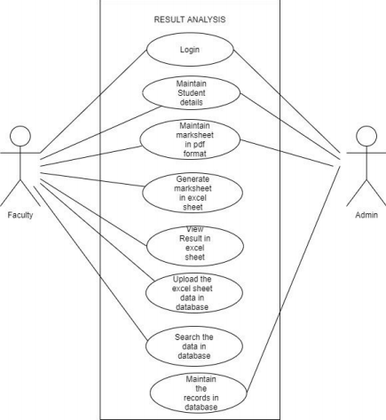

Page No: 8

ANALYSIS & DESIGN

SOFTWARE REQUIREMENTS:

• Operating systems: Windows

• Software Used: MS Excel, Microsoft Visual Studio, Google Chrome • Programming Language: ASP.NET

HARDWARE REQUIREMENTS:

• Intel Core i3 (Processor)

• RAM: 4 GB

• Hard Disk: 15 GB

Page No: 9

FLOWCHART:

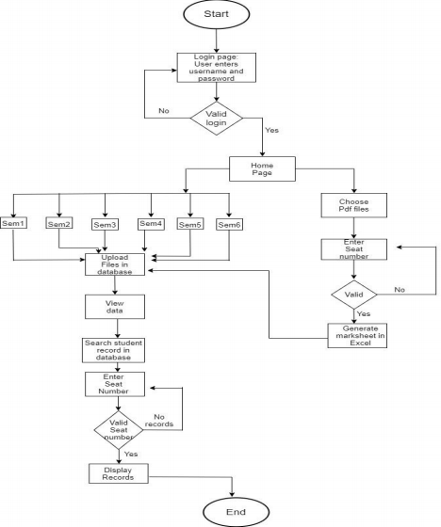

Page No: 10

DATA FLOW DIAGRAM (DFD):

**0 Level DFD (The overview of data flowing in the system**

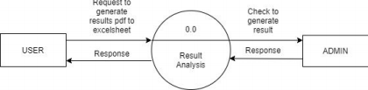

**1st Level DFD (In detail how the data is flowing in all modules)** 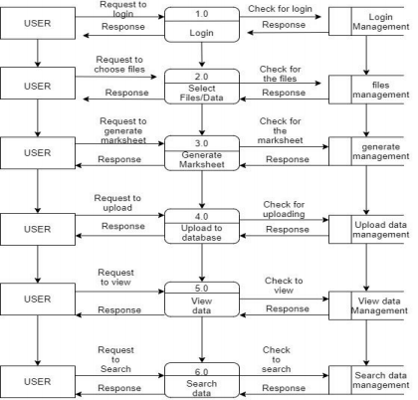

Page No: 11

USER MANUAL

KEY FUNCTIONALITIES OF EACH MODULE:

**A)** **Conversion pdf to excel:** Where a user wants to convert the desired pdf marksheet to be converted into excel format.

**B) Uploading Excel Sheet files in the database:**Where a user can upload the converted file and upload it in the database for future reference. D) **Search a particular record from the database:** When a user wants to search a particular record from the database it can search by giving a valid input seat number and get the desired records of that student.

**OUTPUT SCREENS:**

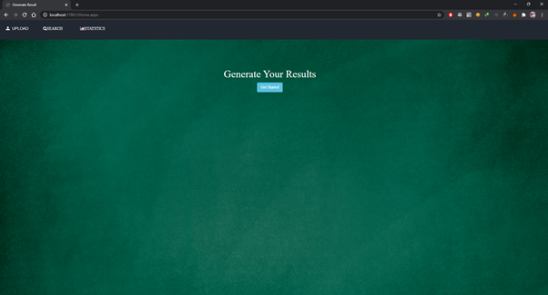

Fig:1.1 Home Page

Page No: 12

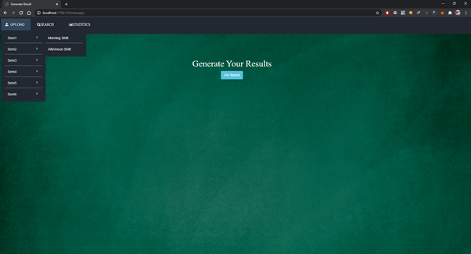

Fig 1.2 Upload Tab

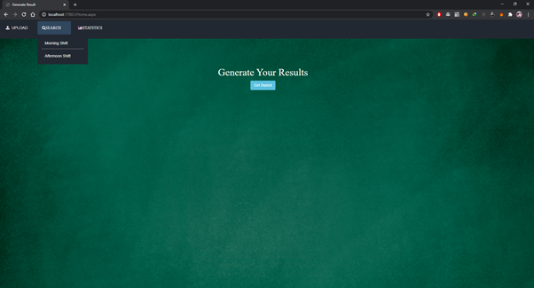

Fig: 1.3 Search Tab

Page No: 13

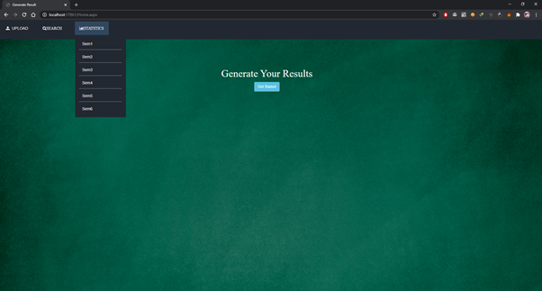

Fig 1.4 Statistics Tab

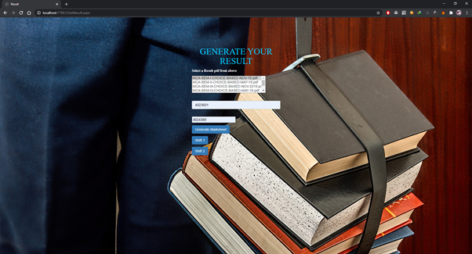

Fig: 2 Selection of pdf marksheet and entering seat number.

Page No: 14

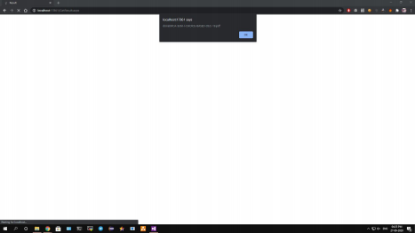 Fig: 3 Process of Conversion of Pdf to Excel sheet.

**RESULT EXCEL FILE**

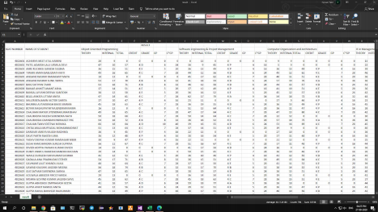 Fig: 4 Pdf marksheet converted to Excel sheet

Page No: 15

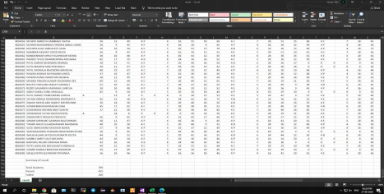 Fig:4.1 pdf marksheet converted to Excel Sheet.

**UPLOAD MODULE**

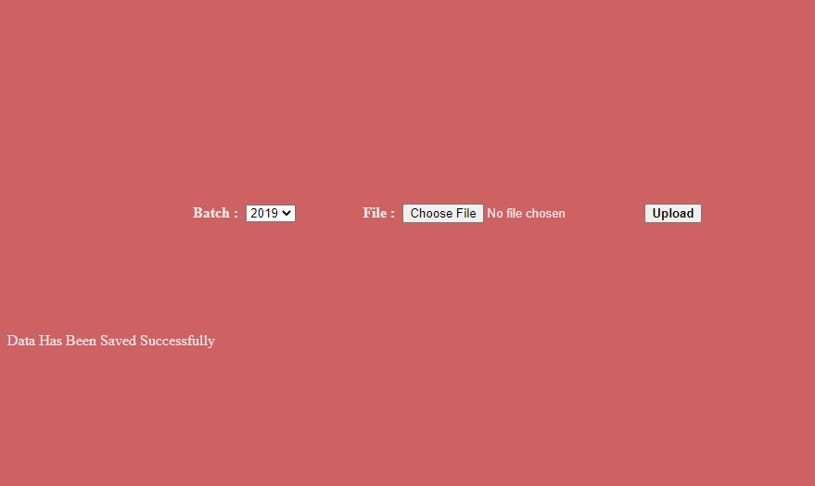

Fig: 5 Upload Page

Page No: 16

**SEARCH MODULE**

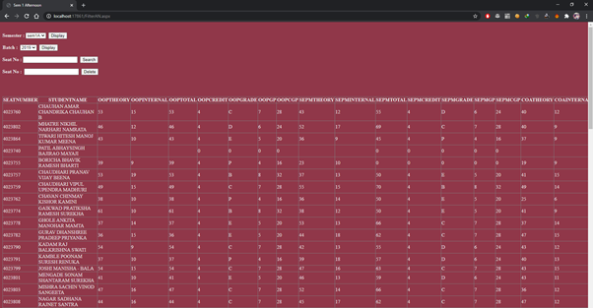

Fig: 6 Search records page

**STATISTICS MODULE**

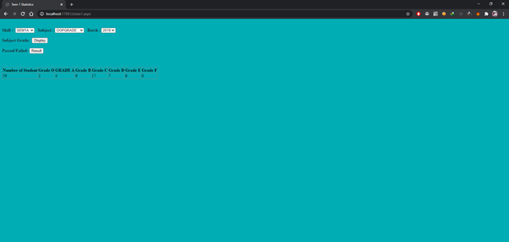

Fig: 7 Statistics page

Page No: 17

CONCLUSION

FUTURE ENHANCEMENT:

There is a huge scope in this system where we can convert the mark sheet into other file formats along with excel sheet. Eg: Word, jpg and jpeg format.Where a user uploads the desired marksheet in the pdf form and it gets converted to the desired file format the user wants as per his requirement this will not only saves time of conversion but also work process will be smooth and efficient.

REFERENCES

BIBLIOGRAPHY:

● Programming ASP.NET Jesse Liberty

● ASP.NET Unleashed, Second Edition Stephen Walther

WEBLIOGRAPHY:

● https://www.tutorialspoint.com/

● https://www.guru99.com/

Page No: 18